Zero-Touch IAM: Addressing Onboarding Delays, Risks, and Manual Inefficiencies
Team Information
Team Name: Zero touch iAMSecurity
Team Members
- Member 1 (lead): name: A, email: B
- Member 2: name: X, email: Y
- …
Partner Name: XXX Submission Sub-Region:

Summary
[Short paragraph to reflect what this submission is about, the problem statement, the solution, and what it could achieve.]
Submission Overview: AI-assisted IAM (Identity and Access Management) provisioning prototype built using Google's Agent Development Kit (ADK). The goal is to demonstrate how multi-agent orchestration, policy retrieval, and human approvals can be automated end-to-end while keeping privileged IAM execution behind an isolated Agent-to-Agent (A2A) surface
Problem Statement
- Current IAM processes depend on manual provisioning, approvals, and policy checks—leading to slow onboarding and inconsistent access.
- Delays in granting and removing access create security risks and audit compliance gaps.
- Identity data is fragmented across systems, making it difficult to maintain accuracy and enforce standardized policies.
- We need Zero-Touch IAM to automate identity lifecycle management and strengthen our security posture.
The Solution:
This project implements an autonomous IAM provisioning orchestration system that combines:
- Multi-agent AI orchestration** using Google ADK
- Agent-to-Agent (A2A) security isolation** for privileged operations
- Policy-aware decision making** with RAG (Retrieval Augmented Generation)
Approval email decisions** with Gmail API (OAuth Authentication)
- Natural Language Understanding** for email-based approval classification
- Temporal compliance guardrails** for time-restricted access
- IAM Policy Application** with Google Cloud Resource Manager
- Comprehensive audit trails** for regulatory compliance (Firestore)

What it could achieve:
- Operational Efficiency: Reduce manual workload for IT and HR teams by automating provisioning/deprovisioning and approvals.
- Security Improvement: Minimize human error, remove stale access quickly, and detect anomalous activity in real time.
- Compliance Assurance: Enforce consistent policy application, maintain clear audit trails, and reduce gaps during access reviews.
- User Experience: Enable a frictionless onboarding experience with immediate access based on policy-driven automation.
- Scalability: Support rapid business growth and cloud expansion with a modern, automated IAM foundation.

Background
[Elaborate the painpoint and the derived use case. Some key aspects you could include are:
- What is this painpoint, and where it exists (industry and location)
1. Manual Identity Provisioning
Where it exists:
- During new hire onboarding
- When employees change roles or departments
- During offboarding
Pain point:
Access creation, updates, and removal depend on manual steps, leading to delays, inconsistencies, and high operational effort
2. Slow and Inconsistent Approvals
Where it exists:
- Access request approval workflows
- Manager and application owner approvals
- Policy-based access exceptions
Pain point:
Approval delays cause long wait times for users to receive required access, impacting productivity and slowing down onboarding.
3. Policy Misalignment and Enforcement Gaps
Where it exists:
- Role-based access policies
- Location- or job-specific provisioning rules
- Segregation of Duties (SoD) and compliance controls
Pain point:
Policies are inconsistently applied across systems, creating over-provisioning, under-provisioning, and compliance risks.

4. Fragmented Identity Data
Where it exists:
- Multiple HR, IT, and application systems
- Disconnected directories and access repositories
- Legacy systems with manual data inputs
Pain point:
Identity inconsistencies lead to failures in provisioning, mismatched user profiles, audit issues, and complicated troubleshooting.
5. Delayed Deprovisioning
Where it exists:
- Employee offboarding
- Contractor and temporary worker exit processes
- Application access revocation workflows
Pain point:
Slow removal of access increases security risk and leaves orphaned accounts active across systems.
6. Lack of Real-Time Monitoring
Where it exists:
- Access activity logs
- Privileged access usage
- Anomaly detection and risk scoring
Pain point:
Limited real-time visibility makes it difficult to detect suspicious access or enforce adaptive authentication.

- Why is it painful and why you would like to address it

1. Delays Impact Productivity
Manual onboarding, approvals, and access provisioning slow down employees from getting the tools and systems they need. This reduces day-one productivity and increases frustration for new hires, managers, and support teams.

2. High Operational Overhead
HR, IT, and security teams spend significant time manually creating accounts, granting access, correcting policy mismatches, and chasing down approvals. These repetitive tasks reduce capacity for strategic work and increase labor costs.

3. Inconsistent and Error-Prone Processes
Manual identity processes lead to inconsistent access assignments and human errors. These mistakes can cause users to receive too much access, too little access, or the wrong access entirely—creating business disruption and security gaps.

4. Compliance and Audit Risks
Inadequate policy enforcement and slow deprovisioning leave organizations exposed to audit findings. Missing access logs, orphaned accounts, and unauthorized privileges create compliance issues across regulated environments.

5. Increased Security Exposure
Delayed removal of access and lack of real-time monitoring increase insider risk and potential misuse. Manual checks cannot keep up with the speed of modern threats, leaving sensitive data vulnerable.

6. Not Scalable for Growth
As the organization expands, manual identity management becomes increasingly unmanageable. More employees, systems, and access needs amplify delays, errors, and operational pressure.

How have other people attempted to solve a similar problem? (If applicable)
Possibly yes.

- What is the impact if you could address
1. Faster and Frictionless Onboarding
- New hires receive access immediately based on policy, without waiting for manual approvals or provisioning.
- Day-one productivity increases, improving the employee experience and reducing onboarding escalations.
2. Stronger Security and Reduced Risk
- Automatic deprovisioning ensures access is removed instantly when users leave.
- Consistent enforcement of policies reduces over-provisioning and prevents unauthorized access.
- Continuous monitoring helps detect suspicious behavior in real time.
3. Major Reduction in Manual Work
- HR, IT, and security teams spend less time on repetitive tasks such as creating accounts, granting access, or fixing policy mismatches.
- Teams can focus on higher-value strategic initiatives instead of operational firefighting.
4. Improved Compliance and Audit Readiness
- Automated logs, standardized policies, and accurate access records simplify audit processes.
- Reduced likelihood of compliance issues related to excessive privileges or stale accounts.
5. Greater Accuracy and Consistency
- System-driven provisioning ensures that users get the correct access every time.
- Fewer errors and less rework due to elimination of manual data entry and human decision inconsistencies.
6. Scalability for Growth
- The IAM model becomes scalable across departments, regions, and new applications.
- Supports cloud adoption, remote workforce expansion, and large hiring cycles without additional operational load.
7. Better User and Manager Experience
- Users get the access they need automatically.
- Managers spend far less time approving routine access requests or dealing with onboarding issues.

For everything you put in the background, industry/market/customer research with information validation is important for evaluation.]

Solution

Solution Description
[Describe what your solution is, how it fits the problem statement and could potentially address it.]

AI-assisted IAM (Identity and Access Management) provisioning prototype built using Google's Agent Development Kit (ADK). The goal is to demonstrate how multi-agent orchestration, policy retrieval, and human approvals can be automated end-to-end while keeping privileged IAM execution behind an isolated Agent-to-Agent (A2A) surface

Solution Design
[Elaborate the solution design, with both domain and technical knowledge. For the domain aspect, leverage your expertise to explain; for the technical part, provide an architecture diagram with elaboration on the components and flow.
Include the unique selling point (USP) of your design, especially when you compare it with similar solutions.]

This project implements an autonomous IAM provisioning orchestration system that combines:
- Multi-agent AI orchestration** using Google ADK
- Agent-to-Agent (A2A) security isolation** for privileged operations
- Policy-aware decision making** with RAG (Retrieval Augmented Generation)
Approval email decisions** with Gmail API (OAuth Authentication)
- Natural Language Understanding** for email-based approval classification
- Temporal compliance guardrails** for time-restricted access
- IAM Policy Application** with Google Cloud Resource Manager
- Comprehensive audit trails** for regulatory compliance (Firestore)
Key Innovation
The system demonstrates Zero-Touch IAM Provisioning where access requests flow through automated policy checks, human approvals, and privilege elevation without manual intervention, while maintaining enterprise-grade security and auditability.

Architecture Diagram
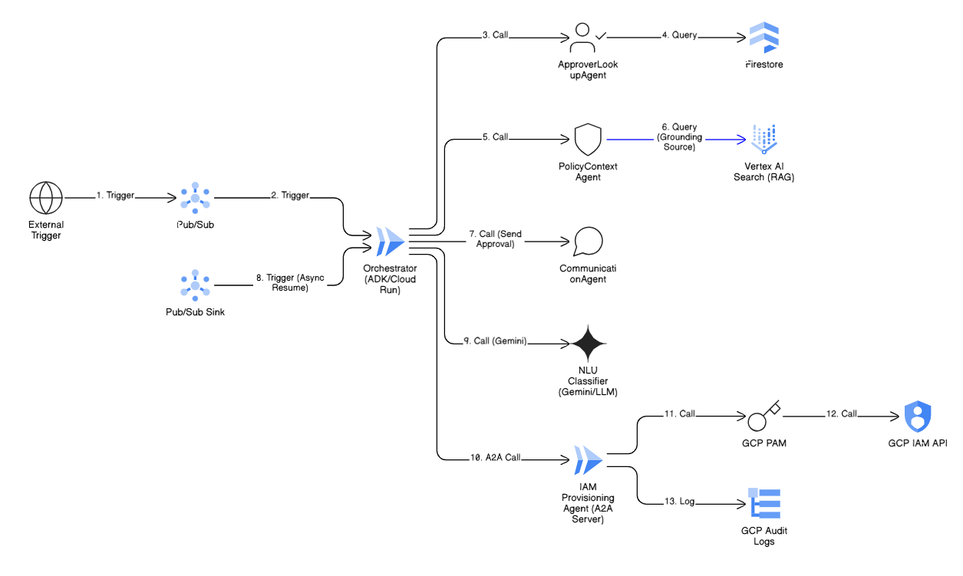

The architecture employs a parent-child hierarchy defined by the BaseAgent structure, utilizing specialized agents for distinct roles. 18 The core control mechanism is the IAM Orchestrator, which acts as the Parent Agent. This agent manages the overall session state, handles error recovery, and performs dynamic delegation using ADK's workflow mechanisms. 2 The overall structure involves specialized sub-agents delegated specific tasks. Table below shows ADK Multi-Agent Architecture for IAM

Agent Name | Primary Function (Reasoning Core) | Key Tools/Services Required | ADK Role Type
IAM Orchestrator | Manages session state, handles dynamic routing (LLM-driven transfer), and error recover | Configuration Store, Cloud Logging | LlmAgent / SequentialAgent [3]
Approver Lookup Agent | Retrieves required approvers and default policy based on user/role ID. | Cloud Firestore Tool, Caching Tool | FunctionTool Agent
Policy Context Agent | Uses RAG to find relevant policy documents and generate compliance justifications. | Vertex AI Search Tool (RAG Backend) | FunctionTool Agent
Communication Agent | Sends approval emails and monitors/triggers the inbound NLU processing. | Application Integration Tool (Email Connector) | FunctionTool Agent
NLU Classifier Agent | Processes inbound email responses, classifies intent, and extracts structured data. | Vertex AI Gemini Tool (Structured Output) | LlmAgent
IAM Provisioning Agent | Securely executes the final policy application or removal via GCP IAM API calls. | Custom IAM Tool (API Wrapper), PAM Credential Manager | Execution Agent

Demo Application URL

GitHub Link
[Private repo, with read access granted to abc-panel@google.com]

Demo Video
[Private Video link, with read access granted to abc-panel@google.com]

Solution Evaluation
[Please include below points and anything you did for agent evaluation:
- How do you plan to evaluate your solution
- How to prepare the data / test cases for evaluation - Sample test cases and respective output]

GTM
[If you would like to commercialize the solution, share a high-level GTM plan. You may also include what Google can do to accelerate the plan.]

What’s Next
[We are not expecting mature, flawless and ready-to-use solutions. Given your submission's potential, elaborate the next steps to complete / enhance the solution.]

Community Contribution (Optional)
Blogs

ADK/A2A/MCP Public Repo Discussion / Raised Issue / Pull Request

ADK/A2A Bug Reported to Google Team
[Include the brief bug description and reporting PE]

